**FOR IMMEDIATE RELEASE**

**Publication Date:** February 6, 2018

**Contact:** Megan Grajeda

512-904-9258 or [megan@cavehenricks.com](mailto:megan@cavehenricks.com)

**THE BOOK OF MISTAKES:**

**9 Secrets to Creating a Successful Future**

by Skip Prichard

# “Success is a riddle, and Skip Prichard’s business parable shines a light on the answer. By exploring the nine mistakes most leaders and entrepreneurs make, Skip helps us turn desire, gratitude, and belief into powerful tools for achievement.”

# *—Michael Hyatt, USA Today bestselling author of Living Forward*

“Skip Prichard’s new book is a helpful reminder about the power of the choices we make in life and leadership.”

***―Doug Conant, Founder of ConantLeadership, Former President of Nabisco Foods Company, Former President and CEO of Campbell Soup Company, and New York Times bestselling author of Touchpoints***

“The essentials of success form the core principles of Skip Prichard's inspiring adventure, *The Book of Mistakes*. Don't miss it!”

―***Ken Blanchard, coauthor of The New One Minute Manager® and One Minute Mentoring***

“In this absolutely brilliant book the author-a noted CEO and highly-regarded business leader-weaves a story (including a heart-racing subplot) that, while greatly entertaining, magnificently educates us with success principles to help us go from where we are to where we want to be. Avoid the mistakes so common to human nature, follow his suggestions on what TO do instead, and watch your business success accelerate and your sense of joy, happiness and peace of mind reach greater heights than you might ever have imagined to be possible. And, definitely buy a copy for every graduate in your life before they step into the real world of business. They will thank you for it! Bravo, Skip Prichard!”

―***Bob Burg, co-author of The Go-Giver***

“If financial success and personal happiness are the Emerald City of Oz, Skip Prichard, in this marvelous book, has paved the perfect Yellow Brick Road to get there. Read it and change your life.”

***―Robert Goolrick, New York Times bestselling author, A Reliable Wife, Heading Out to Wonderful, and The End of the World As We Know It***

You’ve likely heard that genuine happiness at work is rare—two-thirds of people are checked out, unengaged, and generally bored with their jobs. So what’s a business owner, who has to achieve financial goals, to do? In a world where we have only so much power over individual circumstances, how can we inspire employees, millennial and Gen Z generations, and ourselves to do better and take ownership of the present to create room for success in the future?

**THE BOOK OF MISTAKES: 9 Secrets to Creating a Successful Future** (Center Street; February 6, 2018) is the project of Skip Prichard, a CEO who understands that the only motivation that works is self-motivation. Culled from research and interviews with news and sports legends, CEOs, and bestselling authors, **THE BOOK OF MISTAKES** is the inspiring business fable of a young professional named David. Two years into the workforce, David has already become embittered with lost confidence, misdirection, and growing apathy over a list of all-too-familiar stresses. That is, until he’s taken on a journey from “struggling young professional” to “promising entrepreneur, public speaker, and changemaker” by nine sage teachers readying him with the mistakes that lead to failure. These nine mistakes (see pullout for more info), commonly made but rarely addressed, are:

1. Working on someone else’s dream.
2. Allowing someone else to define your value.
3. Accepting excuses.
4. Surrounding yourself with the wrong people.
5. Staying in your comfort zone.
6. Allowing temporary setbacks to become personal failures.
7. Blending in instead of standing out.
8. Thinking there is a fixed and limited amount of success available.
9. Believing you have all the time in the world.

“This book is written to motivate individuals to consistently achieve their own high goals,” Prichard says. “A new training program, an engagement workshop, or a company game room isn’t enough. Creating results and momentum is only possible when employees take personal accountability. That’s what this book is about.”  
  
Showing how you can learn more from other people’s mistakes than successes, **THE BOOK OF MISTAKES** is a fast-paced, thrilling, and instructive story of one man’s transformation from unhappy and stymied to happy and fulfilled that readers of all ages and job levels can learn from.

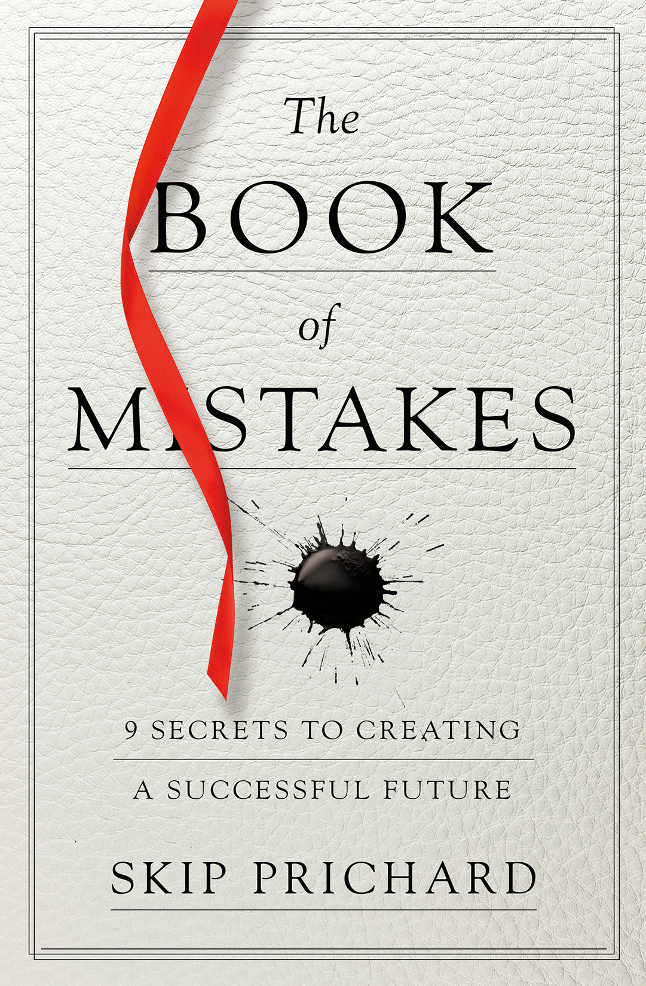**THE BOOK OF MISTAKES: 9 Secrets to Creating a Successful Future**  
by Skip Prichard

Publisher: Center Street  
Hardcover

ISBN: 978-1478970903  
Pages: 192  
Price: $25.00

www.TheBookOfMistakes.com

**ABOUT THE AUTHOR**

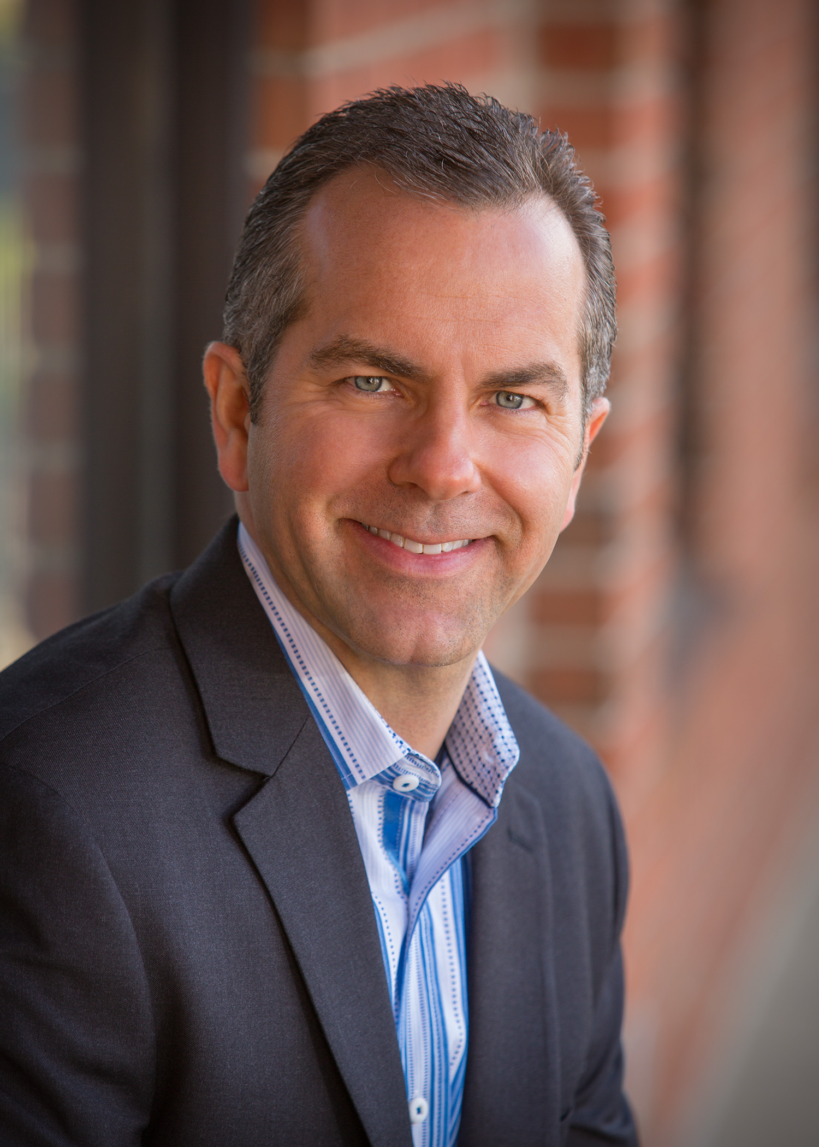  
**Skip Prichard** is an accomplished CEO, growth-oriented business leader, and keynote speaker. He is known for his track record of successfully repositioning companies and dramatically improving results while improving the corporate culture. He is a keynote speaker on topics ranging from leadership, personal development, growth strategies, culture, corporate turnarounds, and the future of publishing. His views have been featured in print and broadcast media including the BBC, The New York Times, CNN, NPR, The Daily Beast, Harvard Business Review, Information Today, The Bookseller, Publishers Weekly, and the Library Journal.

**PRAISE FOR *THE BOOK OF MISTAKES***

“In this wonderful, engaging narrative, Skip Prichard teaches nine timeless principles of success. *The Book of Mistakes* will inspire you to achieve your goals and build a fulfilling life.”

―***Marshall Goldsmith, The Thinkers 50 #1 Leadership Thinker in the World, International bestselling author or editor of 35 books including What Got You Here Won’t Get You There and Triggers***

“An inspirational read packed full of wisdom and advice, *The Book of Mistakes* is a MUST-READ for anyone who wants to move forward from the past and create a positive future!”  
―***Jon Gordon, bestselling author of The Energy Bus and The Carpenter***  
  
“Skip Prichard packs a lot of wisdom into this story. Read it to learn the timeless truths of success from a cast of varied characters, and then share the message with others. This truly is a book for readers of all ages.”  
―***Mark Sanborn, President of Sanborn & Associates, Inc. and author of The Fred Factor***  
  
“Skip Prichard's *The Book of Mistakes*is a compelling narrative and a must-read for anyone who wants to be a better leader and live a life of meaning. If you're in need of a dose of inspiration, you've found it in this book!”  
―***Stephen M. R. Covey, The New York Times and #1 Wall Street Journal bestselling author of The Speed of Trust and coauthor of Smart Trust***  
  
“A riveting reminder that while the clues to success are all around us, ultimately the keys are within the person we see in the mirror.”  
―***Dan Miller, New York Times bestselling author of 48 Days to the Work You Love***  
  
“Prichard's vast experience in publishing is evident in the construction of this delightful and instructive book. *The Book of Mistakes* is not only a tale told well, but it offers life lessons that remind us what matters most, and what to avoid. Reminiscent of *The Alchemist*, this book is an operating instruction for life. It should be a mandatory read for people of all ages, especially those getting ready to launch.”  
―***Lee Woodruff, New York Times bestselling author of Perfectly Imperfect, In an Instant, and Those We Love Most***  
“This is no ordinary story. Within these pages, there exists the power to reinvent your life.”  
―***Andy Andrews, New York Times bestselling author of How Do You Kill 11 Million People?, The Noticer and The Traveler's Gift***  
  
*“The Book of Mistakes* will show you more about success in a few hours than most people come across in decades. Read it, internalize its secrets, and watch your life begin to transform before your eyes.”  
―***Robert D. Smith, author of 20,000 Days and Counting***  
  
“In this engaging story, Skip Prichard gives you a roadmap of mistakes you can avoid on your life's journey. You'll find yourself in these pages, along with a new way to think about success through curiosity, empathy, and action.”  
―***Tim Sanders, author of Love Is the Killer App: How To Win Business and Influence Friends***

“Not only is THE BOOK OF MISTAKES a page-turner that will keep you up at night, it is chock full of lessons you wish you had learned twenty years ago, and the principles for success that you hope to impart to your children, employees, or co-workers.  Skip Prichard has spun a tale that transforms what it means to get ahead in life.”   
***―Ken Abraham, New York Times bestselling author***

“With a refreshing change of style from traditional personal development books, Skip Prichard offers an engaging fable, artfully woven between the past and the present, that will be understood and relished by readers of all ages and walks of life. His *9 Secrets to Creating a Successful Future* are presented in such an interesting and thought-provoking way that you’ll find yourself wanting to highlight, underline, dog-ear pages — anything to ensure that you’ll be able to revisit them again and again.”   
***―Mark Timm, EVP, Ziglar, Inc. & CEO of the most valuable business in the world, The Timm Family***

“An interesting platform for demonstrating the importance of making mistakes and moving forward.”   
***―Tony Hsieh, New York Times bestselling author of Delivering Happiness, CEO of Zappos***

“Skip Prichard’s lessons are right for our time because they are backed by the wisdom of one who has led by example and openly shares his own mistakes. THE BOOK OF MISTAKES is one book that will set you straight on your path to achieving your goals in record time.”   
***―John Baldoni, Inc. Top 50 Leadership Expert, executive coach and author of more than a dozen books on leadership including MOXIE: The Secret to Bold and Gutsy Leadership***

“Skip Prichard masterfully tells a story that keeps you interested and engaged throughout the entire book. I love his message of hope and his belief that our greatest work is always ahead of us not behind us. I highly recommend this book to leaders who aspire to reach their full potential.”   
***―David M.R. Covey, coauthor of Trap Tales: Outsmarting the 7 Hidden Obstacles to Success, CEO of SMCOV***

“THE BOOK OF MISTAKES is an instant classic, a guidebook to achieve success and fulfillment. You’ll find yourself fully immersed in the story and its powerful lessons. Skip Prichard packs each chapter with the wisdom you wished you had years ago. Read it today and change your tomorrow.”   
***―Kevin Kruse, Founder & CEO, LEADx, New York Times bestselling author***

“Skip Prichard’s new book, THE BOOK OF MISTAKES, is not just another book. This one makes a difference! His perspective of the Nine Mistakes covered is life-altering. He creates for the reader an intense awareness of critical mistakes most of us have made and positioned them as an intense, meaningful, learning experience. If you don’t read but one book in the coming year, make it this one!”   
***―Don Hutson, Co-author of the New York Times #1 Best Seller, The One Minute Entrepreneur***

**A Q&A WITH SKIP PRICHARD, AUTHOR OF *THE BOOK OF MISTAKES***

**Q: Why did you write this book?   
A:** This book is designed to empower and encourage. As a CEO, I’ve noticed that the only type of motivation that works is self-motivation. We’ve all read the statistics – 2/3 of employees aren’t engaged – and we often respond with new programs, maybe throw in a game room and an employee picnic. The problem is that these engagement tactics are short-term.

This book is written for those who may not be where they want to be yet, and need a boost of inspiration and ideas to get there. It’s based on my interviews with over 1,000 successful people, on my own experience as a CEO, and on research into success.

**Q: Why did you write it as a story?**

**A:** It’s not only the mistakes and principles in this book that are backed by research, but even the story format. Stanford marketing professor Jennifer Aaker says that “stories are remembered up to 22 times more than facts alone.” I’ve interviewed Paul J. Zak, founding director of the Center for Neuroeconomics Studies who teaches how stories can increase oxytocin production in the brain. This increases our ability to persuade and teach and empathize.

Today, most of us are so busy that we have a harder time sitting down and reading a weighty book full of research. I wanted to write something that you could read in one sitting and enjoy a fictional escape, but walk away with ideas that can change your future. There’s hidden power in a good story.

**Q: From your experience as a noted business leader and interviewer, if you had to choose, what are the top three mistakes people make on their path to success?**

**A:** The nine mistakes in this book were carefully selected. They not only work together, but they interrelate in ways that enhance the learning from an earlier principle. Because of that, it’s easier for me to tell you about the first three. Let’s start with the research on the dying. Researchers find that those dying often regret not living in a way more true to themselves. That forms the basis of mistake #1, which is all about not living someone else’s dream. The second mistake is allowing others to label us falsely, in a way that limits us. Most of us have allowed these negative labels, even those from an early childhood experience, to influence us. The third mistake is accepting excuses. This one really hit home for me when I interviewed Mr. Universe, Rich Gaspari, who is also the CEO of Gaspari Nutrition. I met him after he wrote a powerful book called “No Excuses.” He got back into top shape and appeared on the cover of a magazine decades after the first time, when most of us wouldn’t dream of it. That “no-excuse” mindset applies to many of our goals.

**Q: It’s clear you argue these nine mistakes are timeless—Aria, David, and everyone in between learns and protects them. Why are they still prevalent today?**

**A:** In a world that is transforming in ways we cannot imagine from new social platforms, artificial intelligence, self-driving cars…where 3D printers can print organs in operating rooms and refrigerators can sense we’re low on milk have a drone can deliver it to our front door…even though our world is changing at an unprecedented rate, success principles do not change. Finding our purpose, whether as an individual or as a team, understanding the why behind our actions will be just as important in tomorrow’s technological world as it was in our grandparents’ day.

**Q: Who did you write this book for? If there was only one thing you hope they take from reading it, what would it be?**

**A:** After many of my talks, I am often asked questions that range from how to get promoted to how to handle a difficult boss to how to accelerate growth in a business. This book is for those at inflection points in their life whether a new graduate or a new venture or even a mid-life crisis. It’s designed to help you reflect on where you are so that you can get to where you want to be.

**Q: What’s next for you?**

**A:** I run a wonderful global technology organization for libraries. Libraries are a great equalizer in society, and I’ve seen first-hand how libraries can empower people all over the world. At the same time, I enjoy sharing ideas, insights, and inspiration on my Leadership Insights blog at [www.skipprichard.com](http://www.skipprichard.com). I’m busier than ever, trying to practice the nine principles in the book, and enjoying every moment.

**THE NINE MISTAKES PEOPLE MAKE AT WORK**

1. **Working on someone else’s dream.**Don’t be an unwitting participant in someone else’s plan. Your purpose is unique. Design your life to fulfill your purpose. A clear purpose attracts people, ideas, and resources to its cause.
2. **Allowing someone else to define your value.**A life well lived is a life true to yourself. Don’t accept the limitations others put on you. Enormous power is possible when you give permission to be true to yourself.
3. **Accepting excuses.**Avoid people who encourage excuses. Shift the energy and creativity from creating excuses to achieving goals. Guard your inner voice like you would your most precious treasure.
4. **Surrounding yourself with the wrong people.**Your friends determine your fate. Who you are around determines where you go. Replace naysayers, doubters, and energy drainers with encouragers, winners, and motivators.
5. **Staying in your comfort zone.**Winners seek out the uncomfortable. Leaders consistently push beyond what’s comfortable to stretch to new levels of achievement. Success is the result of consistently and purposely doing the uncomfortable.
6. **Allowing temporary setbacks to become personal failures.**Quickly getting back into the game remolds our experience positively before it has time to harden negatively. A setback is compounded when you allow an unwelcome label to stick. Successful people see temporary failures as stepping-stones to success.
7. **Blending in instead of standing out.**If you fail to stand out, you will be overlooked, passed over, and ignored. Standing out is as simple as consistently outperforming expectations. If you are true to your unique design, you naturally stand out.
8. **Thinking there is a fixed and limited amount of success available.**There is unlimited possibility in the universe. There is no limit to your potential. Be motivated, not intimidated, by another’s success. When someone is doing well, change your mindset from jealousy to curiosity.
9. **Believing you have all the time in the world.**Whether you fulfill your purpose depends on what you do with the present. Knowing your life is limited will keep you focused on the most important part of your purpose. Successful people have a sense of urgency.